**Fruitipedia App - Python Web Basics Exam**

*The app allows the user to browse different fruits including their nutrition info, description, name, and image. The user can create, edit, or delete fruits at any time. He/ She can also edit or delete his/ her profile.*

# **Skeleton**

You are provided with all the needed **HTML pages**, **images,** and **CSS** files for the project.

# **Database**

You will need **2 models**:

### **Profile Model**

* + **First Name**
    - Character field, **required.**
    - It should consist of a **maximum of 25 characters and** a **minimum of 2 characters.**
    - The first name **must start with a letter**. Otherwise raise **ValidationError** with the following message: "**Your name must start with a letter!**"
  + **Last Name**
    - Character field, **required.**
    - It should consist of a **maximum of 35 characters and** a **minimum of 1 character.**
    - The last name **must start with a letter**. Otherwise raise **ValidationError** with the following message: "**Your name must start with a letter!**"
  + **Email**
    - Email field, **required**.
    - It should consist of a **maximum** **of 40 characters.**
  + **Password**
    - Character (password) field, **required**.
    - It should consist of a **maximum of 20 characters and** a **minimum** **of 8 characters.**
  + **Image URL**
    - URL field, **optional**.
  + **Age**
    - Integer field, **optional**.
    - The age **default value should be 18**.

### **Fruit Model**

* + **Name**
    - Character field, **required.**
    - It should consist of a maximum of **30 and** a **minimum of 2 characters**.
    - The name should contain **only letters**. Otherwise raise a **ValidationError** with the following message: "**Fruit name should contain only letters!**"
  + **Image URL**
    - URL field, **required.**
  + **Description**
    - Text field, **required.**
  + **Nutrition**
    - Text field, **optional.**

**Note: the project will be examined only on the user side; models will NOT be tested on the admin site with a superuser profile.**

# **Routes**

* <http://localhost:8000/> - index page
* <http://localhost:8000/dashboard/> - dashboard page
* <http://localhost:8000/create/> - fruit create page
* <http://localhost:8000/<fruitId>/details/> - fruit details page
* <http://localhost:8000/<fruitId>/edit/> - fruit edit page
* <http://localhost:8000/<fruitId>/delete/> - fruit delete page
* <http://localhost:8000/profile/create>/ - profile create page
* <http://localhost:8000/profile/details/> - profile details page
* <http://localhost:8000/profile/edit/> - profile edit page
* <http://localhost:8000/profile/delete/> - profile delete page

# **Pages**

## **Index page - 10p**

**Template file**: **"index.html"**

The page consists of:

* A **navigation bar** with:
* **"Fruitipedia"** link, which leads to the **index** page.
* **"Create Profile"** link, which leads to **create profile** page.
* **"Dashboard"** link, which leads to the **dashboard** page.
* **"Add Fruit"** link, which leads to the **create fruit** page.
* **"Profile"** link, which leads to the **profile details** page.

Keep in mind that the **"Create Profile"** link on the navigation bar is **only visible** when the user **has NOT created a profile yet**:

The **"Dashboard"**, **"Add Fruit"**, and **"Profile"** links on the navigation bar are **only visible** when the user **has a profile:**

## **Create Profile Page - 10p**

**Template file**: **"create-profile.html"**

The page consists of:

* A **navigation bar** with:
* **"Fruitipedia"** link, which leads to the **index** page.
* **"Create Profile"** link, which leads to **create profile** page.
* A **profile** **creation form** consisting of:
* A **"First Name"** field, a placeholder **"First Name"** and **no label**
* A **"Last Name"** field, a placeholder **"Last Name"** and **no label**
* An **"Email"** field, a placeholder **"Email"** and **no label**
  + - * A **"Password"** field, a placeholder **"Password"** and **no label** (When the user enters his/her password, the symbols could be **hidden or visible**)
* A button **"Create"**
* When you **click** on it **if** the profile is **successfully created**, you should be redirected to the **dashboard page**.
* Otherwise, the form should show the **appropriate validation errors in the form**.

## **Dashboard Page - 10p**

**Template file**: **"dashboard.html"**

The **dashboard page shows all fruits which have been created by the user.**

If there are **no fruits created yet**, the page should have the following:

* A navigation bar, as shown below.
* A heading **"No fruit info yet"**

If the **user** **has some** **fruits,** the page should have the following:

* A navigation bar, as shown below.
* A division for each fruit, showing:
* The fruit's **image**
* The fruit's **name**
* The fruit's **description**. The description should show **only** **the first 50 characters!**
* A **button** **"More Info"** leading to the **details page** for the selected fruit

## **Create Fruit Page - 10p**

Template file: **"create-fruit.html"**

The page consists of:

* A **navigation bar,** as shown below.
* A **fruit** **creation form** consisting of:
* A **"Name"** field, a placeholder **"Fruit Name"** and **no label**
* An **"Image URL"** field, a placeholder **"Fruit Image URL"** and **no label**
* A **"Description"** field, a placeholder **"Fruit Description"** and **no label**
* A **"Nutrition"** field, a placeholder **"Nutrition Info"** and **no label**
* A button **"Add Fruit"**
* When you **click** on it **if** the fruit is **successfully created**, you should be redirected to the **dashboard page**.
* Otherwise, the form should show the **appropriate validation errors**.

## **Fruit Details Page - 10p**

Template file: **"details-fruit.html"**

This page contains a fruit’s information. It should have the following:

* The **fruit's image**
* The **fruit's name**
* The **fruit's description**
* The **fruit's nutrition info**, starting with a **paragraph "Nutrition"** (**visible** even if there is **no** nutrition info)
* An **"Edit"** button that leads to the **edit fruit page**
* A **"Delete"** button that leads to the **delete fruit page**

## **Edit Fruit Page - 10p**

Template file: **"edit-fruit.html"**

On the page, the form must be **filled** with **information** about the **fruit** we want **to edit.** Each field has **a label: "Name:"**, **"Image URL:"**, **"Description:"**,and **"Nutrition:"**.

When you click on the **"Edit"** button:

* **If** the fruit is **successfully edited**,you should be redirected to the **dashboard** **page**.
* **Otherwise**, the form should show the **appropriate validation errors**.

## **Delete Fruit Page - 10p**

Template file: **"delete-fruit.html"**

On the page, the form must be **filled** with the **fruit's information**, and **all the fields** should be **disabled.** Each field has **a label: "Name:"**, **"Image URL:"** and **"Description:"**.

When you click on the **"Delete"** button, the **fruit** is **deleted from the database**, and you should be redirected to the **dashboard page**.

The deleted fruit should be **no longer visible in the app**.

## **Profile Details Page - 10p**

Template file: **"details-profile.html"**

This page contains the **user's information**. It should have the following:

* A **profile** **picture**. If **no picture is given**, the page should show a **default profile picture** (in the static/image folder)
* **First name** and **last name**:
* The **email**
* The **age**
* The **total number of posts** that the user has. Display **0**(zero) if there are **no** **posts**.
* An **"Edit"** button that leads to the **edit profile page**
* A **"Delete"** button that leads to the **delete profile page**

**If the user has a profile picture:**

**If the user doesn't have a profile picture:**

## **Edit Profile Page - 10p**

Template file: **"edit-profile.html"**

On the page, the form must be **filled** with the **information** of the **profile** we want **to edit. The profile** **edition form** has **additional fields as shown below**:

* A **"First Name:"** field
* A **"Last Name:"** field
* An **"Image URL:"** field
* An **"Age:"** field

All fields have **labels**.

When you click on the **"Edit"** button:

* **If** the profile is **successfully edited**,you should be redirected to the **profile details page**.
* **Otherwise**, the form should show the **appropriate validation errors**.

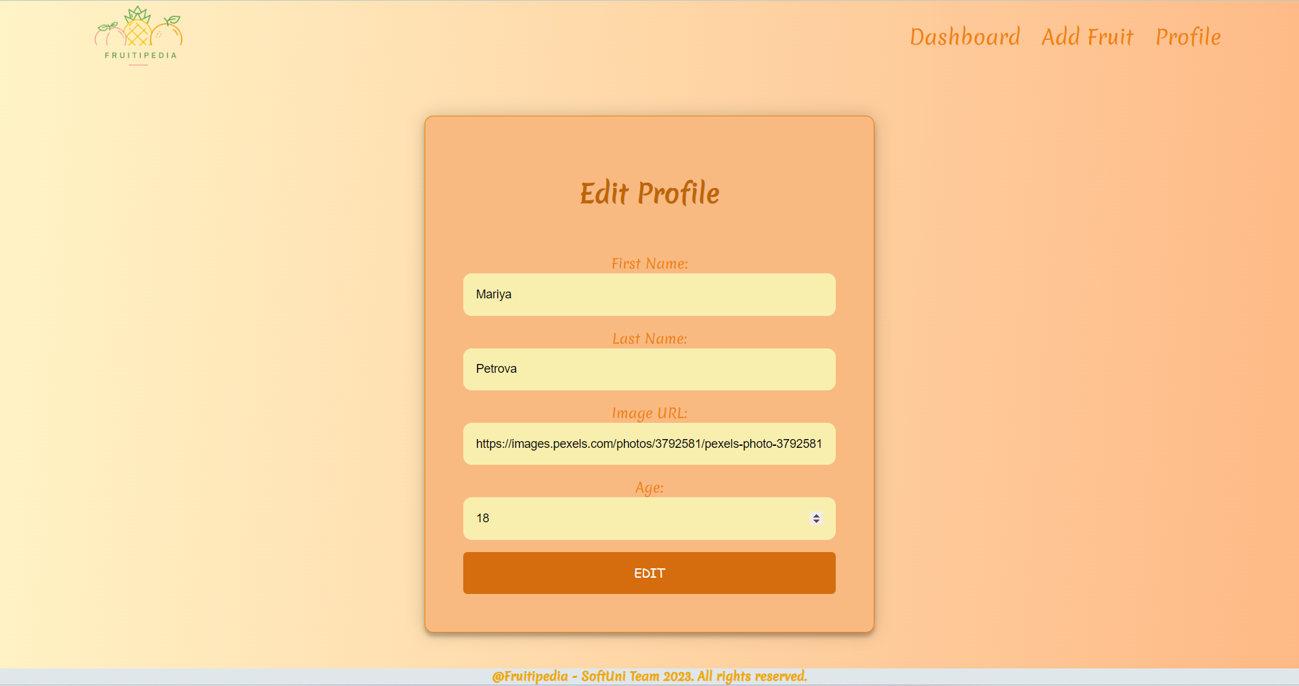

## **Delete Profile Page - 10p**

Template file: **"delete-profile.html"**

Deleting a profile should delete the profile info and **all of his /her added fruits.** After **deletion**, the user should be redirected to the **index page**.

